



**YOU can be a lifesaver**

**Date and time:** Tuesday 29th April 6pm – 7pm

**Location:** St Mary’s CE Primary School, Garnet Road, Willesden, NW10 9JA

**How to sign up:** Use this QR code or the link below to secure your place and reserve your FREE ticket.

<https://www.eventbrite.co.uk/e/1253172605999?aff=oddtdtcreator>

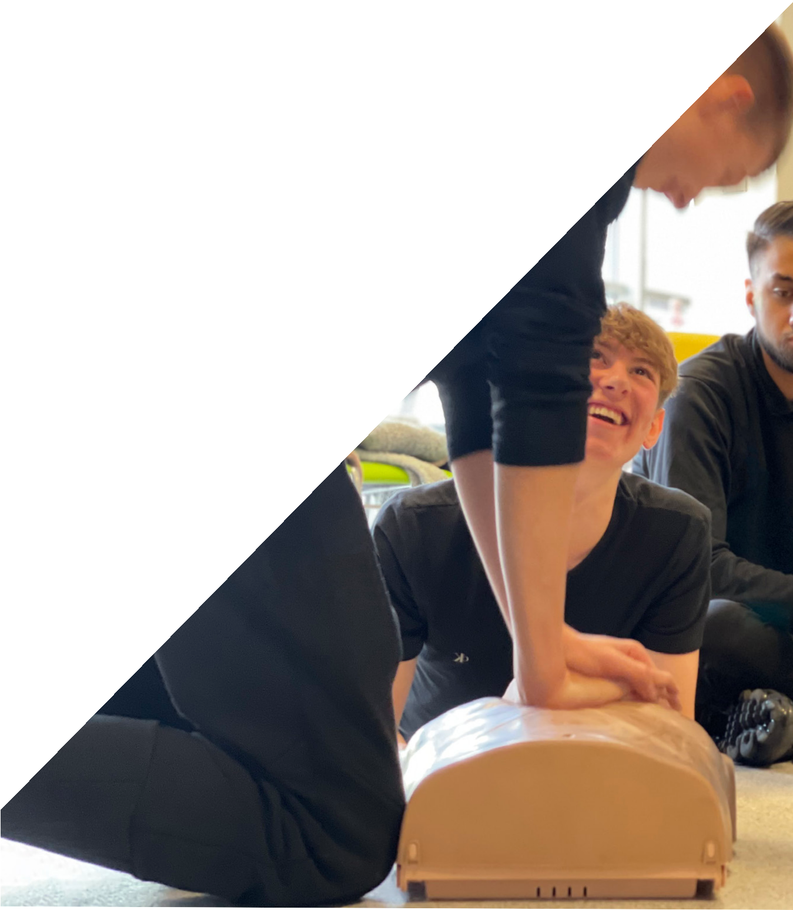

Free First Aid Training

Trigger warning: references to blood, overdosing, mental health, violence, injury, death.

**What to do if someone is knocked out**

Find out how to check for breathing, call an ambulance, put somone in the recovery position or do CPR and *save a life*.

You will get a certificate for completing this training.

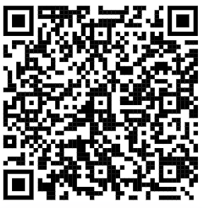

Follow @streetdoctors

[www.streetdoctors.org](http://www.streetdoctors.org/)

Charity number: 1150925