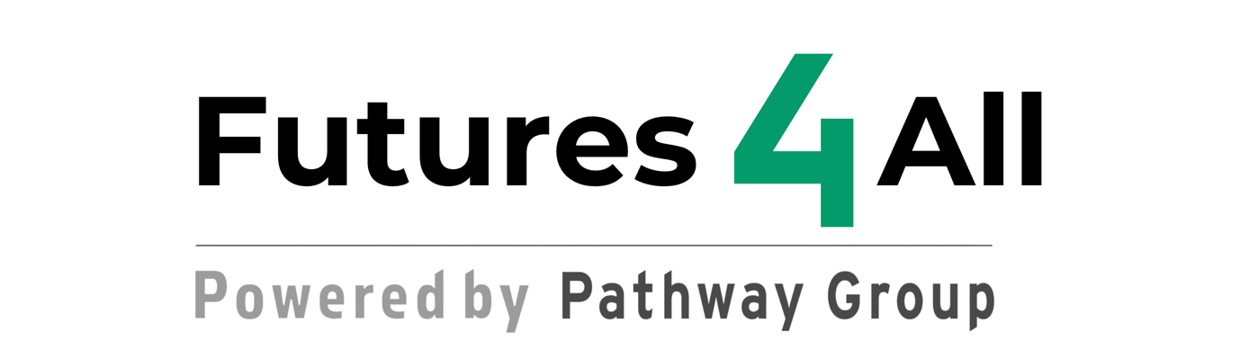

Rationale
Futures4All Programme

Futures4All is committed to empowering young care leavers by providing a community-driven, experiential learning environment that enriches their lives and career opportunities. Our mission is to collaborate closely with local businesses, cultural institutions, and community groups to offer a wealth of networking opportunities and hands-on experiences. Through these partnerships, we enable our learners to apply knowledge and skills in real-world scenarios, solidifying their learning and enhancing their employability. We strive to create transformative educational experiences that not only meet the unique needs of each participant but also prepare them to confidently navigate and succeed in the modern world.

Programme Objectives and Delivery

- Experiential Learning Model: Futures4All stands out by emphasising hands-on, practical experiences over traditional classroom learning. This model facilitates real-world application of skills, bridging the gap between theoretical knowledge and practical application, thereby enhancing the employability and life skills of participants.
- Cultural Capital Enhancement: Through a carefully designed curriculum that incorporates interactions with cultural institutions and local businesses, the programme significantly enhances the cultural capital of participants. This exposure fills the gaps in their previous educational experiences, broadening their understanding of the world and enriching their social and cultural perspectives.
- Community-Driven and Collaborative Learning: The programme's structure involves collaboration with community groups, businesses, and cultural organisations, which not only enriches the learning environment but also embeds a strong sense of community connection and responsibility in participants.
- Comprehensive Support System: Aligning with the Equality Act 2010, Futures4All provides a holistic support framework that includes mentoring, financial advice, and health care services, ensuring that participants' broader needs are met alongside their educational goals.

Curriculum Design
Central to the Futures4All Programme is our commitment to learner autonomy, particularly in the design of the curriculum. By actively involving participants in shaping their learning experiences, we empower them to take ownership of their educational journey. This participatory approach not only boosts their confidence and engagement but also ensures that the learning content is highly relevant to their personal and professional aspirations. Engaging learners in curriculum design fosters a deeper understanding of the material, encourages critical thinking, and enhances problem-solving skills, all of which are vital for their success in the workforce and beyond.
Exemplary Modules and Expected Outputs/Outcomes

The programme includes a variety of modules tailored to meet specific UKSPF evidence requirements such as life skills engagement (OP48), social inclusion (OP52), and familiarisation with employers' expectations (OC41). Example modules include:

- Parenthood Simulation and Early Years Education: Participants gain hands-on experience in childcare techniques, directly enhancing their employability within the Early Years sector.
- Forest Skills and Team Building: Activities designed to improve teamwork and leadership skills, meeting the requirements for increased employability through interpersonal skills development (OC45).
- Multicultural Exchange Day: Aims to foster cultural appreciation and competence, crucial for modern, diverse workplace environments.
- Coastal Discovery and Team Challenge: This module combines environmental education with personal development activities at the seaside. Participants engage in beach clean-up efforts and team-building exercises such as sandcastle competitions or coastal scavenger hunts. This outing provides practical learning opportunities in ecology and conservation while fostering teamwork and community involvement. This module aims to meet the social inclusion (OP52) and interpersonal skills development requirements (OC45).

Innovative Assessment and Continuous Improvement

- Flexible Assessment Methods: Beyond traditional assessments, the programme utilises reflective journals, peer evaluations, and project-based assessments to capture the nuanced skills and knowledge gained through experiential learning.
- Continuous Feedback Mechanism: Regular feedback sessions and the dynamic adjustment of the curriculum ensure that the programme remains responsive to the needs and experiences of the participants, aligning with ongoing evaluation frameworks.
Conclusion

Futures4All is uniquely positioned to transform the lives of young care leavers through a curriculum that is not only designed by them but also tailored to fill the specific gaps in their learning and experiences. By leveraging community resources and providing extensive support, the programme ensures comprehensive personal and professional development, setting a new standard in specialised educational programmes. This approach not only meets but exceeds the UKSPF's requirements for effective, impactful learning interventions aimed at NEET populations.

